# Name: omar nour Mohamed

# B.N : 571

# e-mail: Omar196631@feng.bu.edu.eg

# topic : programming languages

# brief:

A programming language is a computer language programmers use to develop software programs, scripts, or other sets of instructions for computers to execute.

Although many languages share similarities, each has its own syntax. Once a programmer learns the languages rules, syntax, and structure, they write the source code in a text editor or IDE. Then, the programmer often compiles the code into machine language that can be understood by the computer. Scripting languages, which do not require a compiler, use an interpreter to execute the script.

Screenshots:

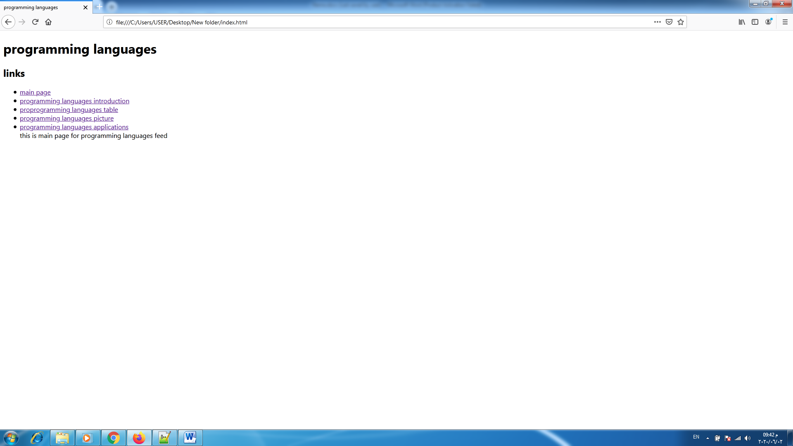

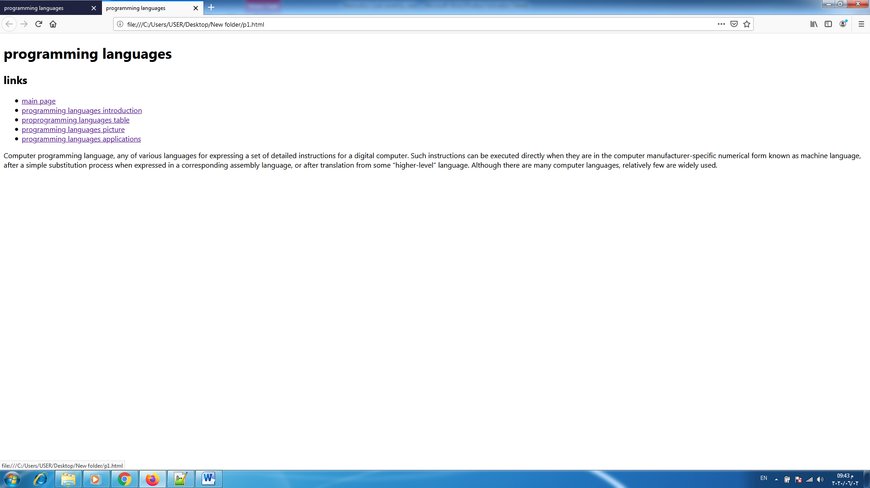

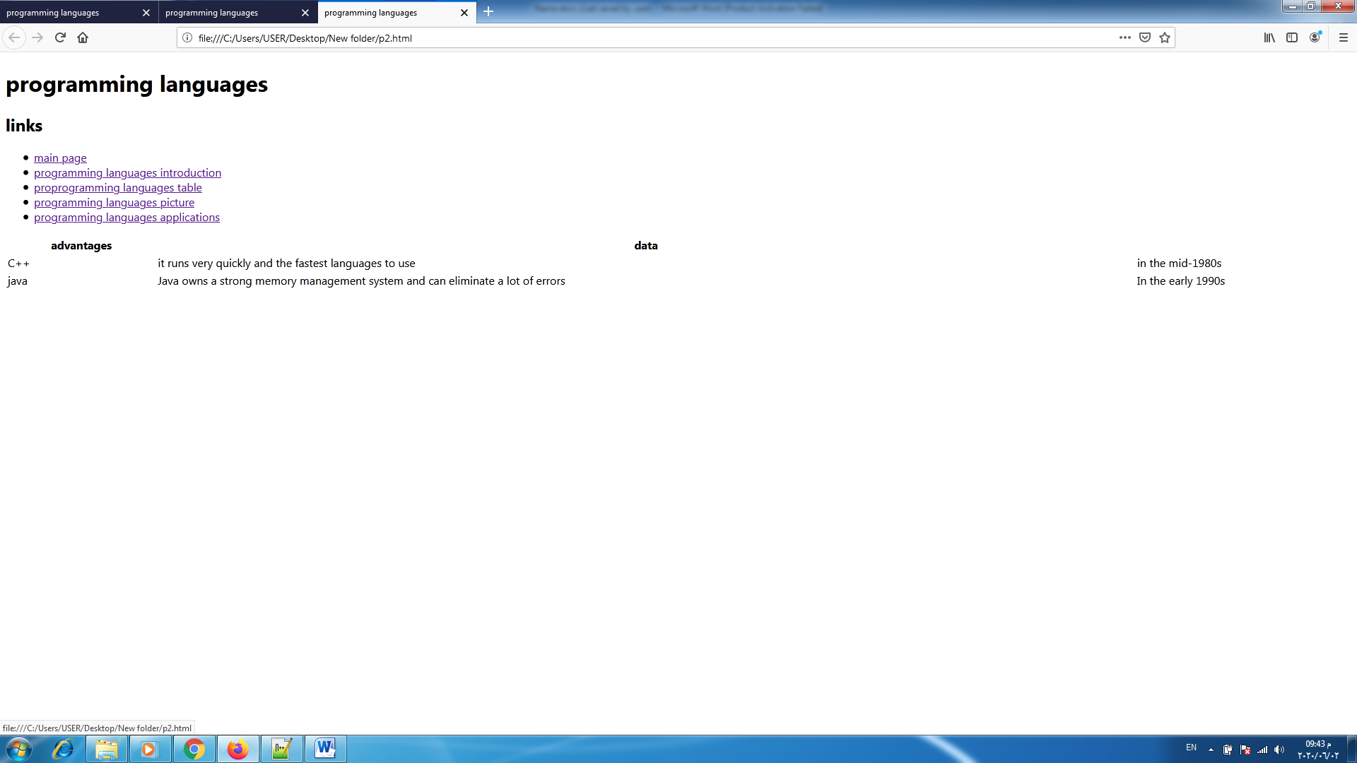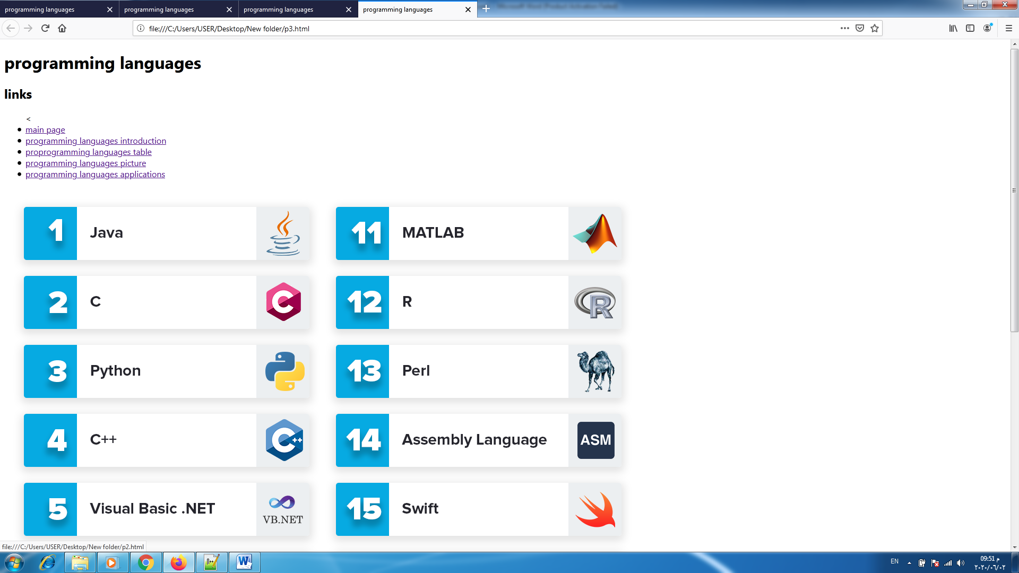

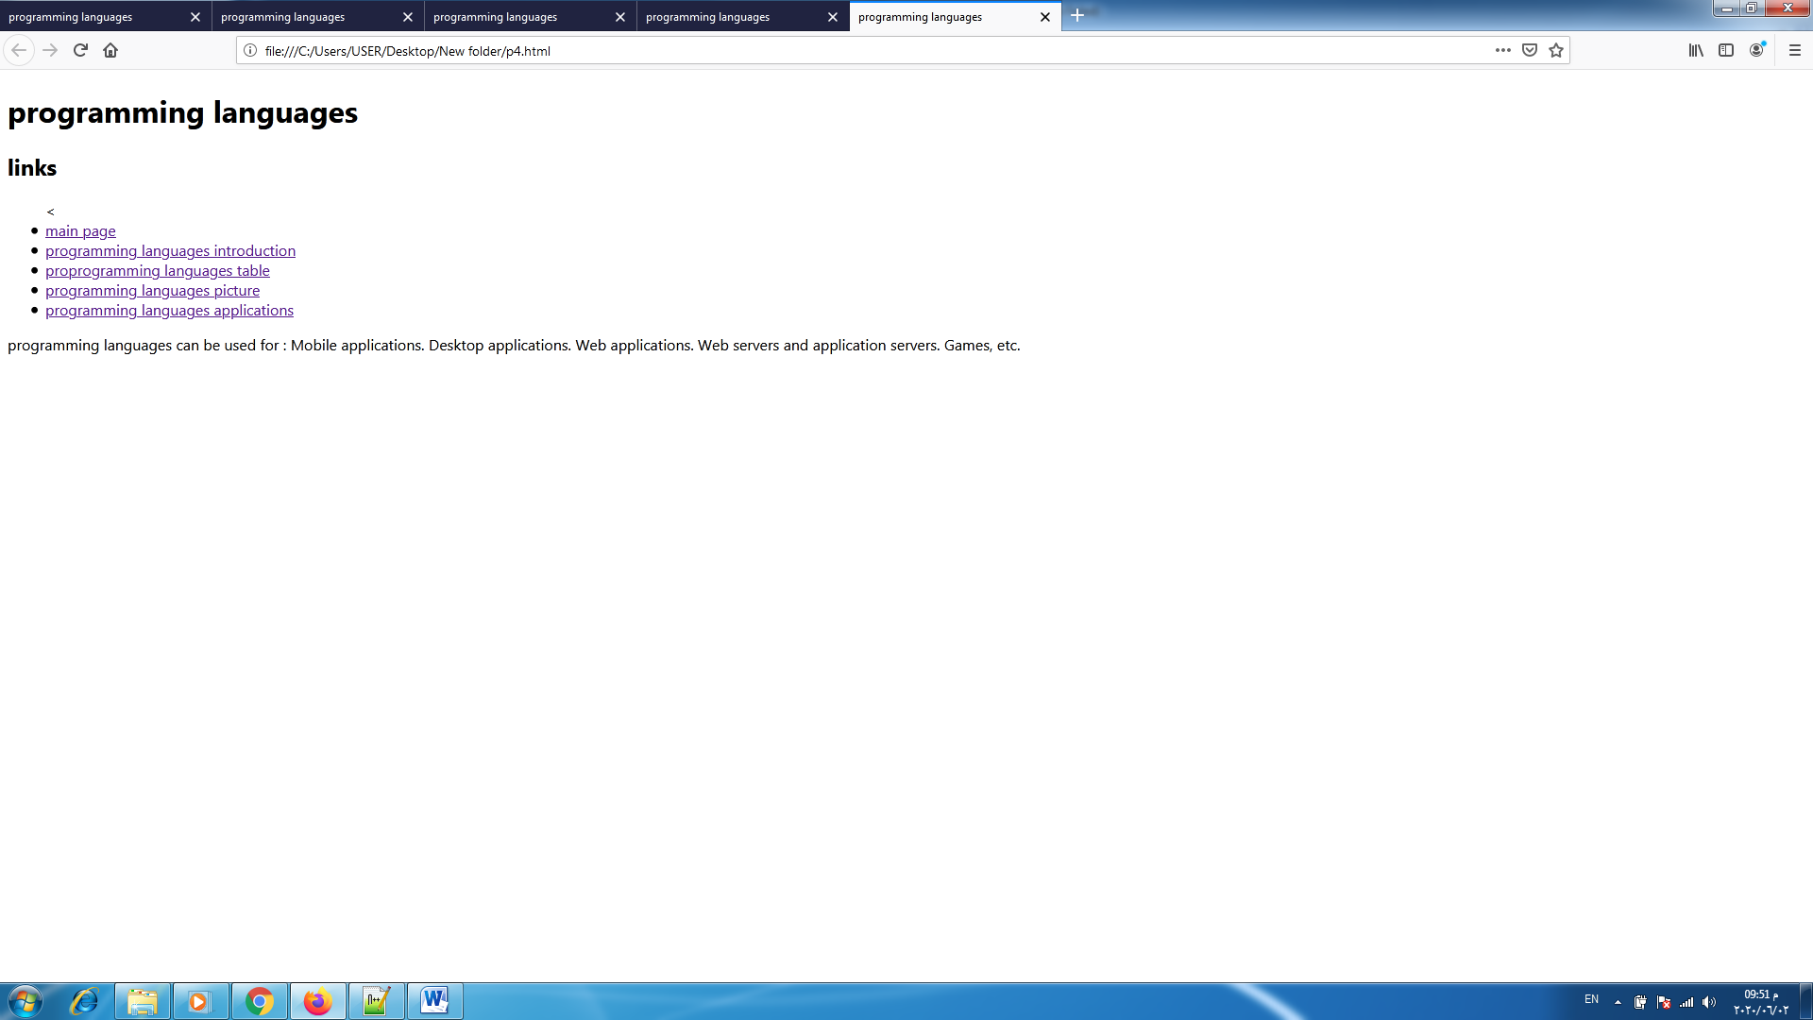

# Source code:



 

